Customer Transaction Escalation System

David Graves
Colorado State University Global
CSC501
Dr. Bingdong Li
September 19, 2024

Stakeholder Engagement Matrix
A critical part of every project is having a clear understanding of who the key stakeholders are and identifying how engaged they are in relation to a project. One artifact and tool in a Project Managers toolbelt is the Stakeholder Engagement Matrix, of which Sebastian (2024) in his online article shares “… is a simple yet powerful project management technique to document desired and monitor actual engagement levels of stakeholders.” The matrix uses five different levels of engagement ranging from “unaware” to “leading” which provides a PM a clear holistic line of sight regarding what relationships may need to be nurtured and can help identify possible blockers from disenfranchised groups. I’ve provided a sample matrix in Image 1 below showing five different stakeholders and their current level of engagement, noted with a “C” as well as the PM’s desired level of engagement for them, noted with a “D”.
Image 1
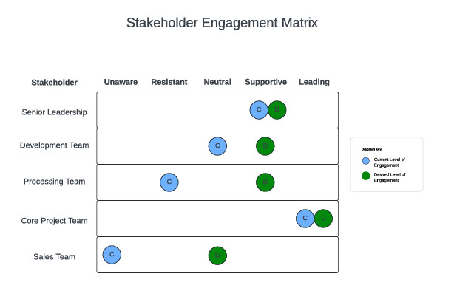
Stakeholder Use Cases
In reviewing the matrix presented above one can quickly see where the teams sit in relation to each other and to the overall project. The Sales Team is currently “unaware” of the work that is happening, which could mean a couple of different things. In this example it’s not necessarily a bad thing though. This snapshot is from early in the project and although this tool would ultimately help the business get things done and hopefully help the sales team close more leads, they wouldn’t be direct users of the tool and should be engaged farther in the development chain to show and share, bringing them to at least a desired state of “neutral”. Moving one line up on the matrix we see that the Core Project team is the only team currently at the “leading” level which makes sense as the Core Project team has a lot to do out of the gate and spends lots of time setting the table for future success. The PM should keep an eye on this group to ensure that they maintain a high level of engagement throughout the project. The Processing Team is next on the list and the first one where, as a PM, I would look to take action to move closer to their desired state of “supportive” from where they currently sit at “resistant”. As mentioned, this snapshot is early in the project, and it’s expected that a proposed change that would directly affect this group’s daily work might meet resistance. The Development Team currently sits at “neutral” which is ok for now since they haven’t been given too much direct action to take yet and haven’t been able to sink their teeth into the project. Finally, the last group is Senior Leadership, who sit at their desired level of “supportive” which is critical to project success. These are the folks that write the checks and can help a PM eliminate roadblocks when they arise. Overall, this is a reasonable starting point for a project, and I’d be comfortable with the state of things as they sit, with a little bit of work to bring everyone along.

Reference
Sebastian (2024). project-management.info. Stakeholder Engagement Assessment Matrix: Uses & Example.
Stakeholder Engagement Assessment Matrix: Uses & Example [PMP®-relevant] - Project-Management.info

